To load the map data into Compendium:
- Download the map data XML zip file (by clicking on the link above) and save it to your local hard drive.
- Open Compendium and navigate to the view where you want to load the new knowledge map into.
- Open the folder that you saved the map data XML zip file into (1).
- Drag and drop the XML zip file into Compendium.
- You will be shown a dialog. Select "Process Drop as Compendium XML Zipped" and click on "Process Drop..." (2).
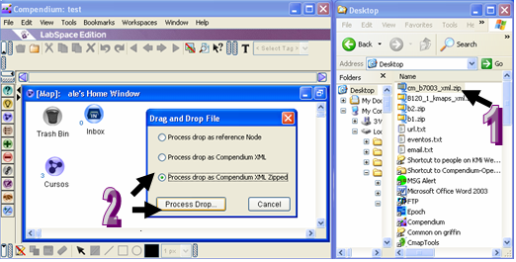

- The XML import dialog will then appear. Complete the details as per below:
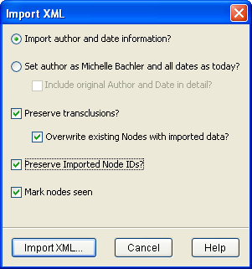

- Press "Import XML". You will see a progress bar appear showing the status of the map data loading.
- Once the progress bar has completed, you should see the newly imported map node appear in the current view.

